الاسم :- امير صابر السيد

سكشن :- 1

مسلسل :- 20

الرقم الاكاديمي :- 1200639

**Task description:-** the client sends the radius for a circle to server through DataOutputStream on the output stream socket, then the server receives radius through DataInputStream on the input stream socket. The server computes the area and send it to client through DataOutputStream on the stream socket, then client receives area through DataInputStream on the input stream socket. The process can be repeated more than once and only one client can connect to server at same time..  
**notes:-**

1. First run server.java then run client.java In order for the program to work correctly..
2. Here, I used java swing to build GUI

**Libraries used:-**

java.io.*; java.net.*;

javax.swing.*; java.awt.*; java.util.*;

java.awt.event.ActionEvent; java.awt.event.ActionListener;

**-java.io :-**

To use DataInputStream and DataOutputStream to get input and output stream and exchange data between server and client. The input stream and output stream used to read or write bytes

**-java.net :-**

To create and establish network between client and server by using ServerSocket and Socket classes.

**At server side :-**

ServerSocket server = new ServerSocket(port);

Socket socket = new Socket();

Socket = server.accept();

**At client side :-**

Socket socket = new Socket (host , port);

**-java.awt, java.awt.event.ActionEvent and java.awt.event.ActionListener :-**

 The AWT (Abstract Window Toolkit) provides an interface between a Java application and a native windowing system. AWT comprises the event handling system as well as a set of so-called heavyweight GUI components, including the top-level components such as frames and dialogs.

**-javax.swing :-**

To draw graphical user interface such as panel and text area and text field

**Server**

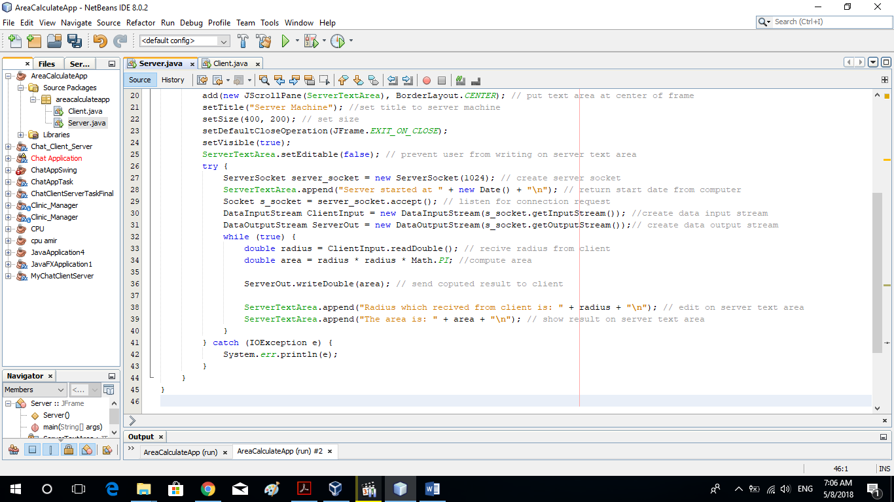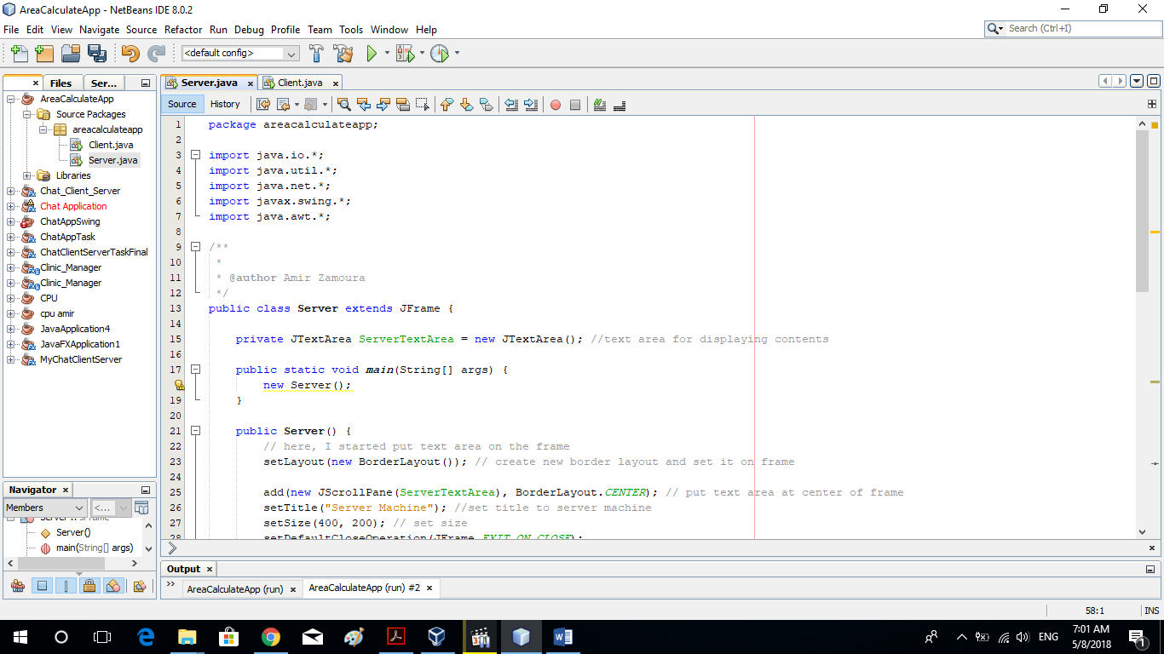

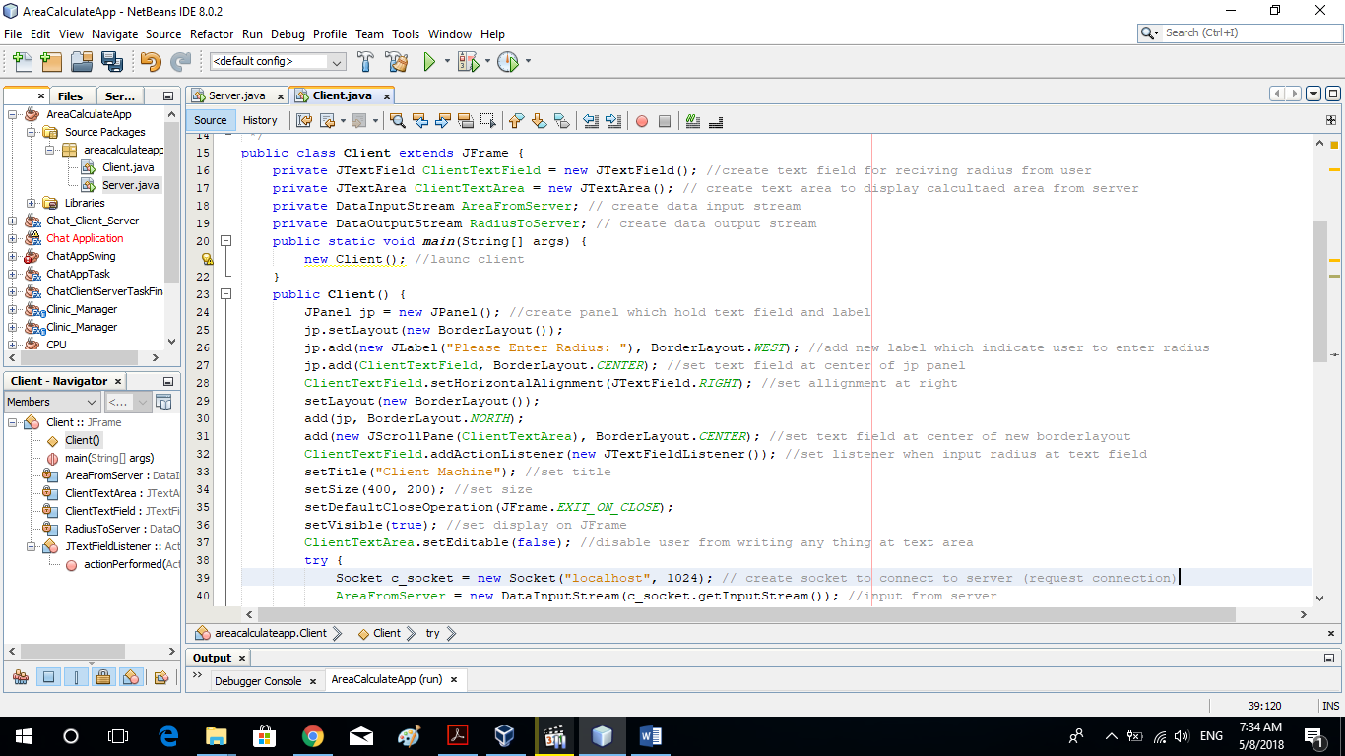Client

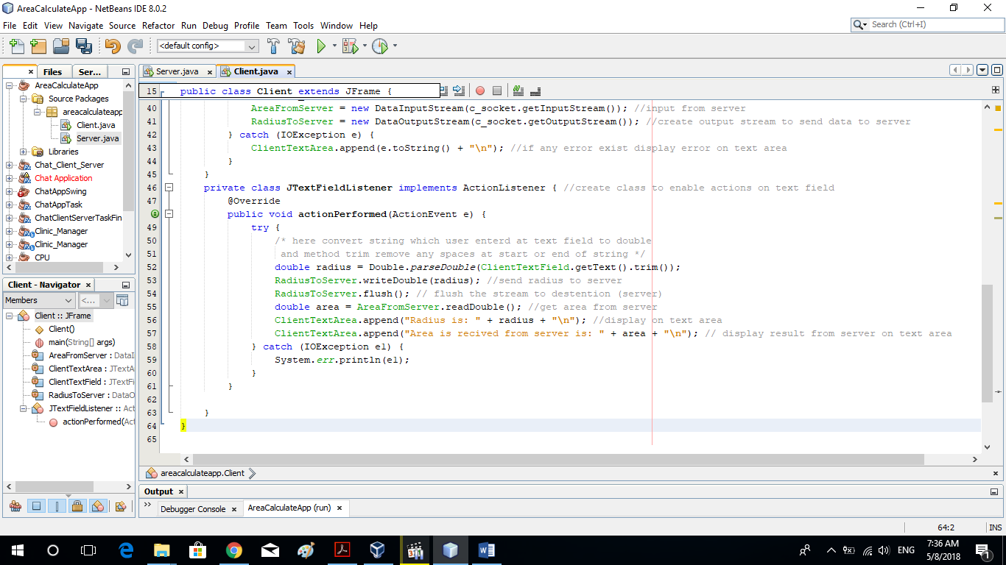

Screen from program

